Object Oriented Programming
- Definition: A programming paradigm that revolves around the concept of “objects.”
- Key Features:
- Objects: Hold both data (attributes) and behavior (methods).
- Reusability, modularity, scalability.
- Why OOP?: Simplifies code management, promotes reusability, and models real-world systems.
Four Pillars of OOP
- Introduction: The four foundational concepts that make OOP work effectively.
- Encapsulation
- Abstraction
- Inheritance
- Polymorphism
Encapsulation:
- Bundling of data and methods within a class
- Key concept: Hides the internal state of an object and only exposes a controlled interface
- Benefits: Protects the internal state, promotes modularity, and prevents unintended access
- Utilizes getters and setters to access components of a method (in other languages?)
- __ also used to set a particular parameter as private in python
- Example:
- 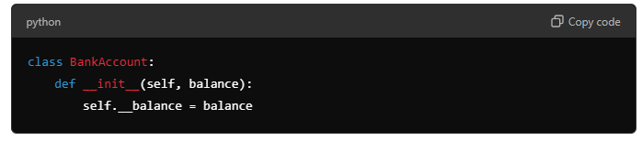
Abstraction:
- Abstraction focuses on hiding implementation details and only showing the necessary parts
- Key concept: What an object does, not how it does it
- Benefits: Simplifies complex systems on focusing on high-level functionality
- Specific type of abstract includes abstract methods, which can get confused with the larger concept of abstraction
- 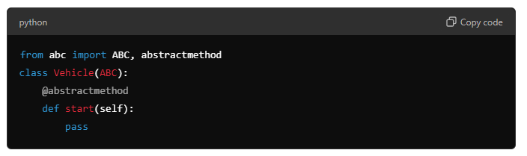
Inheritance
- Inheritance allows one class (child) to inherit attributes and methods from another class (parent)
- Key Concept: Promotes code reuse and hierarchical class structures
- Types: Single, multiple (unique to python), and multilevel inheritance
- Subclasses and superclasses
- 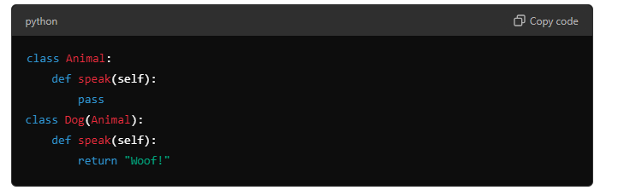
Polymorphism
- Definition: Polymorphism allows methods to do different things based on the object it is acting upon.
- Key Concept: Same interface, different behavior.
- Benefits: Flexibility in code design and maintenance.
- 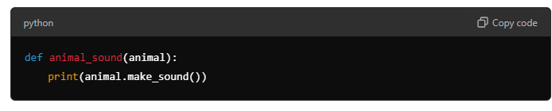
Comparing the Four Pillars
- 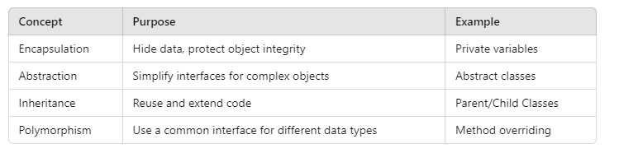
- Abstraction and encapsulation tend to go together
- Inheritance and polymorphism tend to go together
Real World Applications
- OOP is used in a variety of fields:
- Game Development
- Web Applications
- GUI Design
- Systems Development
- Example: OOP principles in designing a transportation system (e.g., Cars, Bikes, Buses all as subclasses of Vehicle).
Summary
- Encapsulation: Controls access to the internal state.
- Abstraction: Simplifies complexity by focusing on essential details.
- Inheritance: Promotes reusability through hierarchical class structures.
- Polymorphism: Flexibility to handle objects of different types through a common interface.
- OOP helps in building scalable, maintainable, and reusable code.
Reading ideas on composition/aggregation
- Composition is a way of aggregating objects together by making some objects attributes of other objects. We saw in the previous chapter how we can make a datetime.date object an attribute of our Person object, and use it to store a person’s birthdate. We can say that a person has a birthdate – if we can express a relationship between two classes using the phrase has-a, it is a composition relationship.
- Relationships like this can be one-to-one, one-to-many or many-to-many, and they can be unidirectional or bidirectional, depending on the specifics of the the roles which the objects fulfil.
- According to some formal definitions the term composition implies that the two objects are quite strongly linked – one object can be thought of as belonging exclusively to the other object. If the owner object ceases to exist, the owned object will probably cease to exist as well. If the link between two objects is weaker, and neither object has exclusive ownership of the other, it can also be called aggregation.
- Here are four classes which show several examples of aggregation and composition:
- Think of linktree as use of aggregation for social media platforms/apps

